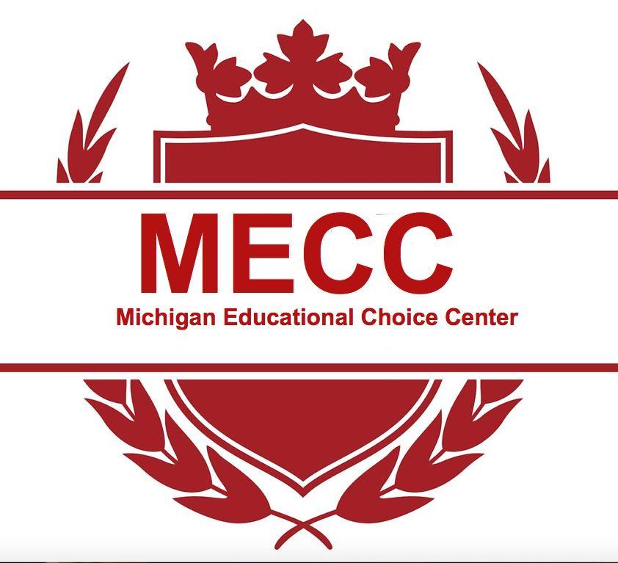
Academic Goals 2021-2022
Goal Category | Goal Related to Student Achievement or Growth on K- 8 Benchmarks | Benchmark Assessment Name | Related to either Student Achievement or Growth on Benchmark Assessments (Achievement or  Growth?) | Aligned to Covid-19 Learning Plan from 2020-21 (Y/N)
Middle of Year Reading Goal | 50% of scholars will meet their growth goal as measured by NWEA | NWEA | Growth Goals | Yes
Middle of Year Mathematics Goal | 50% of scholars will meet their growth goal as measured by NWEA | NWEA | Growth Goals | Yes
End of Year Reading Goal | 100% of scholars will meet their growth goal as measured by NWEA | NWEA | Growth Goals | Yes
End of Year Mathematics Goal | 100% of scholars will meet their growth goal as measured by NWEA | NWEA | Growth Goals | Yes
PA 48 of 2021 Section 98b

